Egypt, Arab Rep.

## GNI per capita and development level

The data set shows the GNI per capita and development level of the country each year.

## # A tibble: 19 x 5  
## country iso3c date GNIperCapita devCategory   
## <chr> <chr> <dbl> <dbl> <chr>   
## 1 Egypt, Arab Rep. EGY 1996 1718. Lower Middle Income  
## 2 Egypt, Arab Rep. EGY 1998 1845. Lower Middle Income  
## 3 Egypt, Arab Rep. EGY 2000 1991. Lower Middle Income  
## 4 Egypt, Arab Rep. EGY 2002 2025. Lower Middle Income  
## 5 Egypt, Arab Rep. EGY 2003 2046. Lower Middle Income  
## 6 Egypt, Arab Rep. EGY 2004 2088. Lower Middle Income  
## 7 Egypt, Arab Rep. EGY 2005 2142. Lower Middle Income  
## 8 Egypt, Arab Rep. EGY 2006 2267. Lower Middle Income  
## 9 Egypt, Arab Rep. EGY 2007 2395. Lower Middle Income  
## 10 Egypt, Arab Rep. EGY 2008 2519. Lower Middle Income  
## 11 Egypt, Arab Rep. EGY 2009 2568. Lower Middle Income  
## 12 Egypt, Arab Rep. EGY 2010 2593. Lower Middle Income  
## 13 Egypt, Arab Rep. EGY 2011 2566. Lower Middle Income  
## 14 Egypt, Arab Rep. EGY 2012 2573. Lower Middle Income  
## 15 Egypt, Arab Rep. EGY 2013 2562. Lower Middle Income  
## 16 Egypt, Arab Rep. EGY 2014 2584. Lower Middle Income  
## 17 Egypt, Arab Rep. EGY 2015 2656. Lower Middle Income  
## 18 Egypt, Arab Rep. EGY 2016 2724. Lower Middle Income  
## 19 Egypt, Arab Rep. EGY 2017 2763. Lower Middle Income

## GDP growth and economic growth classification

The data set shows the GDP growth and the ecomic growth classification of the country each year.

## # A tibble: 19 x 5  
## country iso3c date GDPannualGrowthRate GDPgrowthCategory4  
## <chr> <chr> <dbl> <dbl> <fct>   
## 1 Egypt, Arab Rep. EGY 1996 4.99 moderate growth   
## 2 Egypt, Arab Rep. EGY 1998 5.58 fast growth   
## 3 Egypt, Arab Rep. EGY 2000 6.37 fast growth   
## 4 Egypt, Arab Rep. EGY 2002 2.39 slow growth   
## 5 Egypt, Arab Rep. EGY 2003 3.19 moderate growth   
## 6 Egypt, Arab Rep. EGY 2004 4.09 moderate growth   
## 7 Egypt, Arab Rep. EGY 2005 4.47 moderate growth   
## 8 Egypt, Arab Rep. EGY 2006 6.84 fast growth   
## 9 Egypt, Arab Rep. EGY 2007 7.09 fast growth   
## 10 Egypt, Arab Rep. EGY 2008 7.16 fast growth   
## 11 Egypt, Arab Rep. EGY 2009 4.67 moderate growth   
## 12 Egypt, Arab Rep. EGY 2010 5.15 moderate growth   
## 13 Egypt, Arab Rep. EGY 2011 1.76 slow growth   
## 14 Egypt, Arab Rep. EGY 2012 2.23 slow growth   
## 15 Egypt, Arab Rep. EGY 2013 2.19 slow growth   
## 16 Egypt, Arab Rep. EGY 2014 2.92 moderate growth   
## 17 Egypt, Arab Rep. EGY 2015 4.37 moderate growth   
## 18 Egypt, Arab Rep. EGY 2016 4.35 moderate growth   
## 19 Egypt, Arab Rep. EGY 2017 4.18 moderate growth

## Development trend

The plot shows the development trend of the country.

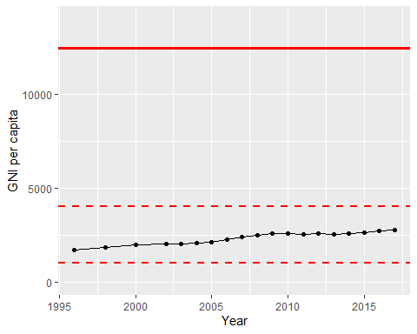

GNI Per Capita Trend